Absenteeism at Work

Roli Srivastava
Analytics
Abstract- Absenteeism is defined as employee’s absence from work. By default, all employees are expected to take days off work. However, this costs companies in terms of loss of productivity, quality of work and financially. There are several reasons for absenteeism which include from high competitiveness, increasingly audacious goals, overburdening work which may lead to many health conditions. The purpose of this paper is present different machine learning techniques that can be applied to predict reasons for absenteeism at work. Random Forest, Linear Regression, Naïve Bayes Classifier, Support Vector Machine (linear, radial and poly) techniques were used in this paper.
Keywords—Random Forest, Linear Regression, Naïve Bayes Classifier, Support Vector Machine

Introduction
The database used in this paper is the information collected from absenteeism records from work during the period of July’2007 to July’2010 in a Courier company. The company is having issue of Absenteeism. By applying multiple machine learning techniques, we are attempting to answer two main questions: predict of absenteeism at work and what changes company should bring to reduce the number of absenteeism.
The dataset consists twenty-one (21) attributes that are Individual identification (ID), Reason for absence (ICD), Month of absence, Day of the week, Seasons, Transportation expense, Distance from Residence to Work (in kms), Service time, Age, Work load Average/day, Hit target, Disciplinary failure, Education, Number of children, Social drinker, Social smoker, Pet, Weight, Height, Body mass index, Absenteeism time in hours. The reason for absence attribute has a total of twenty-eight (28) categories, of which twenty-one (21) categories are attested by International Code of Diseases (ICD) and seven (7) categories without the ICD. The overview of the dataset is shown in Figure 1.
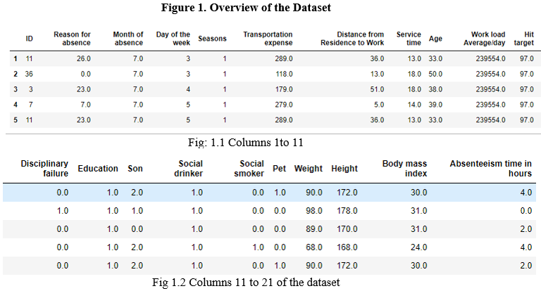

There are eight (8) categorial variables and twelve (12) numeric variables. The dependent variable or target variable for the analysis is Absenteeism (in hours) i.e., number of hours employees are absent from work. This target variable is converted into a categorial variable into three groups: Group 1 (0 hours), Group 2 (less than and equal to six (6) hours) and Group 3 (greater than six (6) hours). As a first step to analysis, we investigate the observations to find out any missing values, checking for outliers, etc. Table-1 lists the number of missing values for all the attributes in the dataset. Only hit target and weight have missing variables. The following pre-processing was performed to the dataset prior to analysis: a. rather than deleting all the rows containing more than one NA; b. they were replaced with mean values, converted the string values to numeric values in the numerical column like ‘WorkloadAverageday’.
Attribute | Number of Missing Values
ID | 0
Reason for absence | 0
Month of absence | 0
Day of the week | 0
Seasons | 0
Transportation expense | 0
Distance from Residence to Work | 0
Service time | 0
Age | 0
WorkloadAverageday | 0
Hit target | 1
Disciplinary failure | 0
Education | 0
Son | 0
Social drinker | 0
Social smoker | 0
Pet | 0
Weight | 2
Height | 0
Body mass index | 0
AbsentHrs | 0
Table-1. Missing Values by Attribute
Additionally, correlation analysis was performed to check for multicollinearity. The analysis result showed that Body mass index was redundant variable, hence dropped before any imputation task.

Data Visuvalization
We cannot undermine the fact that, though simple, barplots present the best results in getting us the feel of dataset. Thus, will be seeing important variables’ plots, mostly with our target variable. The result of graphs can change to an extent that it can lead to changes in answer if we use imputed/processed dataset for plotting graphs. Figure 2a shows the mean of hours that persons with ID from 1 to 36. Person with ID: 6, 16, 21 had the greatest number of hours absent, while ID: 19, 29 had the least number of hours of absenteeism. Fig 2b shows the distribution of reason of absence in percentages used by employees over the whole period. It shows that reason 23(medical consultation) is the most prominent reason amongst all, as it is the most evident reason and the most generic one, apart from this 4.8 percent of employees haven’t stated their reason of absenteeism which is reason 26(unjustified absence). The least reason stated by employees for being absent are 3 (Diseases of the blood and blood- forming organs and certain disorders involving the immune mechanism), 2(Neoplasms) 16, 17 etc. these reasons are also anyhow very uncommon to see in our daily life. Note that, there is 0.1 percent of reason of absence number 0, which should not have been there. Fig 2.c shows the mean of number of hours that employees have been absent for reason. It shows that reason 9(Diseases of the circulatory system), 2,3,5,6,15,18,24 has the most longing effect on the number of hours of absenteeism on employees, and the least ones were 16 (Certain conditions originating in the perinatal period), 27(physiotherapy) etc.

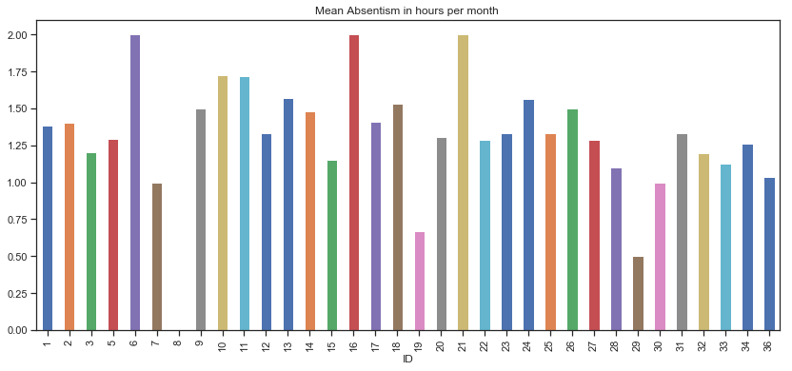
Figure 2a. Mean Absenteeism Hours for each ID
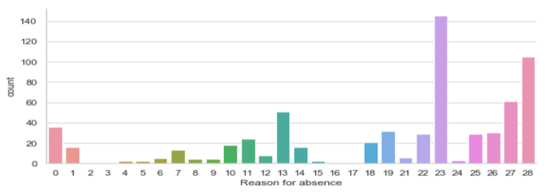
Figure 2b. Percentage of the Reason of Absence used by Employees
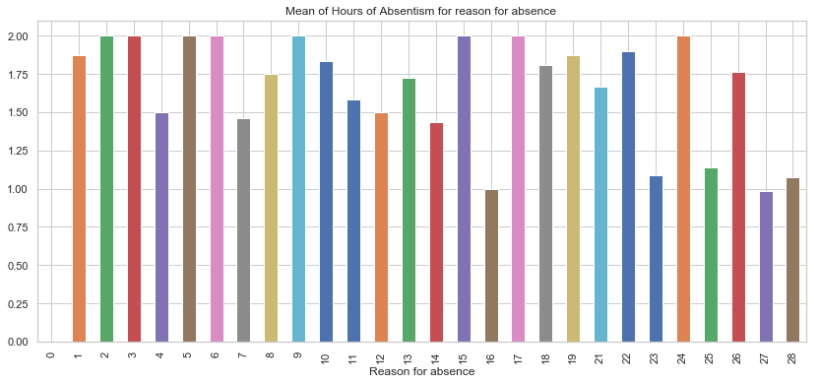

Figure 2c. Mean Absenteeism hours for each reason of absence

Figure 2d shows the mean of absenteeism hours spread over different Aged people. It suggests that the greatest number of skipping of hours is seen in elderly people, while the youngest lot seems good in remaining present. Figure 2e shows that Monday and Tuesday had the most amount of absenteeism hours, while Thursday, middle day of the week, had the least hours of absenteeism. Figure 2f shows that around 58.4% of people are social drinkers, while very less percentage of people ~7% are social smoke

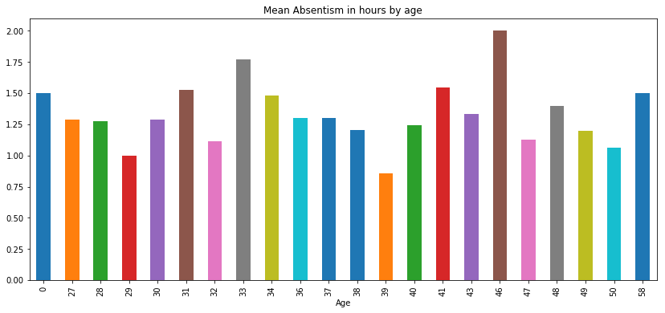
Figure 2d. Mean Absenteeism in hours by age

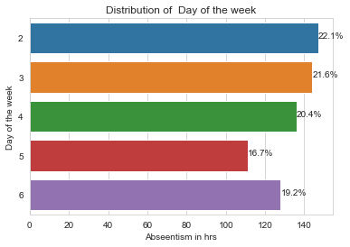
Figure 2e. Mean absenteeism Hours for day of the week
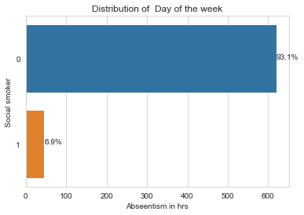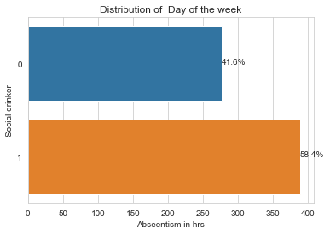
Figure 2f. Count of Instances of Smoking and Drinking

Analysis
Feature Selection
Feature Selection reduces the complexity of a model and makes it easier to interpret and reduces overfitting. Features are selected based on their scores in various statistical tests for their correlation with the outcome variable. Correlation plot is used to find out if there is any multicollinearity between variables. The highly collinear variables are dropped and then the model is executed. From correlation analysis, it was determined that Weight and Body Mass Index have high correlation (>0.80), so the Body Mass Index was excluded. Table 2 shows that reason for absence, day of the week and workload are amongst the main features in deciding absenteeism, while variables like education and social smoker doesn’t really helps in determining our target variable. However, we would include all the variables except BMI since the variables are less and are carrying at least some importance in determining our target variable
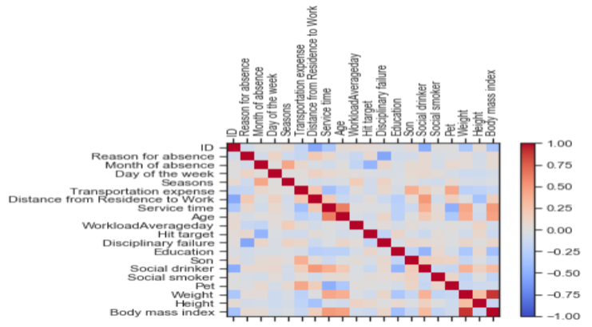

Figure 3. Correlation Matrix

Attribute | importance
Reason for absence | 0.329820
Transportation expense | 0.119763
WorkloadAverageday | 0.076952
Day of the week | 0.073981
Hit target | 0.070660
Month of absence | 0.062964
Seasons | 0.041434
ID | 0.038833
Weight | 0.033823
Height | 0.031189
Age | 0.030279
Distance from Residence to Work | 0.029712
Service time | 0.026838
Son | 0.017969
Pet | 0.010050
Education | 0.004185
Social drinker | 0.001547
Disciplinary failure | 0.000000
Social smoker
Table2: Reason for absence importance

Feature selection was performed using Principal Component Analysis (PCA) and Linear Discriminant Analysis (LDA). Both the analysis showed the same features i.e., Reason for absence, Disciplinary failure, Day of the week, WorkloadAverageday, Transportation expense and Month of absence are important. Figure 4 and Figure 5 shows the analysis result from PCA and LDA analysis.
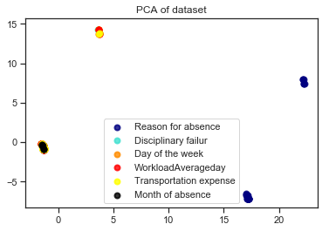

Figure 4. Pricipal Component Analysis (PCA)
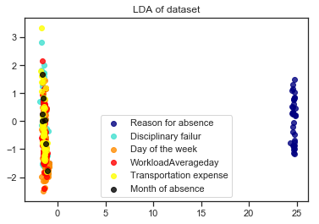

Figure 5. Linear Discriminant Analysis (LDA)
Outlier detection and treatment is always a tricky part especially when our dataset is small. The box plot method detects outlier if any value is present greater than (Q3+ (1.5 * IQR)) or less than (Q1–(1.5* IQR)). Figure 6 shows the distribution of the Absenteeism in hours. Figure 7 shows the number of outliers for each variable. It was observed that most of the outliers like height, number of pets, age etc. were feasible data, so only imputed absenteeism in hours. Using Z score method, we imputed absenteeism in hours. We found that the number of dropped observations were 141.

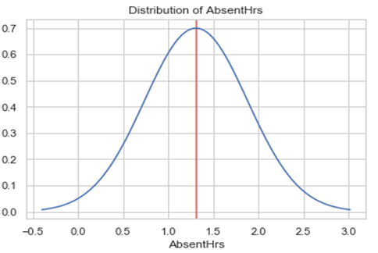
Figure 6. Distribution of Absenteeism in hours

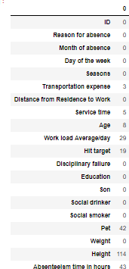

Figure 7. Outliers for each variable

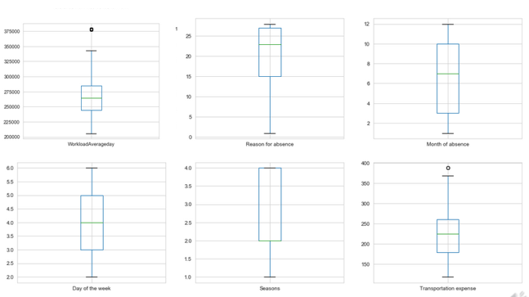

Figure 8. Box plot for important features

Feature Scaling
It was observed that many numerical variables had different ranges of value, some huge and some small, so just to stay assured that large values don’t dominate our model, feature scaling was performed, and all variables’ values were brought in between 0 to 1. After checking for missing data, data preprocessing, identifying important features and normalizing the target data, the data is ready to run different machine learning models.

Model Development

Decision Tree, Random Forest, Naïve Bayes Classifier, Support Vector Machine – Linear, Radial and Polynomial models were developed and tested to see the performance on the dataset. Accuracy and RMSE are taken as the measure of model performance.
Decision Tree Classifier: The values of train RMSE is close to 0 which suggests that there is over-fitting problem in this model, thus a regularized model of Decision tree is needed to treat it. It has an accuracy of 78.09% on the training data and 66.66% on the test data. The RSME is 0.48 and 0.08 for the training and test data respectively. Figure 9 shows the Decision Tree Classifier.

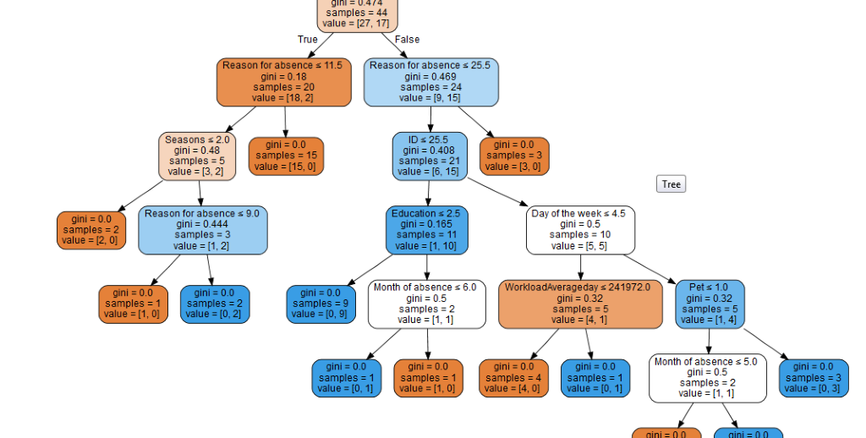
Figure 9. Decision Tree Classifier

Random Forest: The solution to the previous model of decision tree gets exactly served by the regularized method, Random Forest. Notice that regularized method helps when there is over-fitting in traditional methods. But, here in random forest the score has increased considerably from 3 to 4 with train value also getting better than decision tree’s model. It has an accuracy of 82.85% on the training data and 66.66% on the test data. The RSME is 0.20 and 0.16 for the training and test data respectively.

Naïve Bayes Classifier: It has an accuracy of 75.24% on the training data and 41.66% on the test data. The RSME is 0.50 and 0.31 for the training and test data respectively.

Support Vector Machine – Linear: It has an accuracy of 64.76% on the training data and 58.33% on the test data. The RSME is 0.61 for the test data respectively.

Support Vector Machine – Radial: It has an accuracy of 63.80% on the training data and 50.0% on the test data. The RSME is 0.63 for the test data respectively.

Support Vector Machine – Poly: It has an accuracy of 63.80% on the training data and 50.0% on the test data. The RSME is 0.63 for the test data respectively.

Linear Regression: Additional analysis was performed by treating the Absenteeism variable as continuous. Multiple Linear Regression was performed to predict number of hours in Absenteeism. An R-square of 0.95 and Adjusted R-square of 0.928 was obtained. In Figure 10, We noticed that R-square value was high, and F-statistics was also a good number indicating a good model. In the coefficient, it was seen again the reason of absence, day of week and transportation expense was significantly impacting the model.

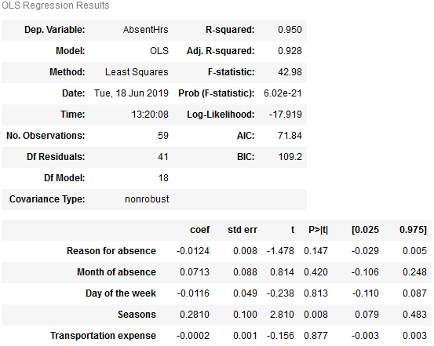

Figure 10. Linear Regression

Decision Tree  Accuracy 66.66% test  Accuracy 78.09% train  Result-test  RMSE: 0.4879500364742666  Result-train  RMSE: 0.08451542547285165 | Naive Bayes classifier  Accuracy 41.66% test  Accuracy 75.24% train  Result-test  RMSE: 0.7637626158259734  Result-train  RMSE: 0.4976133515281193 | Linear Regression  RSQR: 0.950  test  RSQR:0.928 train  Result-test  RMSE: 0.32558217860  Result-train  RMSE: 0.37865840754
Random Forest
Accuracy 66.66% test
Accuracy80.95% train
Result-test
RMSE: 0.2158938847941864
Result-train
RMSE: 0.17200740570989267
Support Vector Machine Linear  Accuracy 58.33 % test  Accuracy64.76% train  Result-test  RMSE: 0.6454972243679028 | Support Vector Machine radial  Accuracy is 50.0% test  Accuracy 63.80% train  Result-test  RMSE 0.7071067811865476 | Support Vector Machine poly  Accura50.0% test  Accura63.80% train  Result-test  RMSE: 0.7071067811865
Figure 11. Comparison table

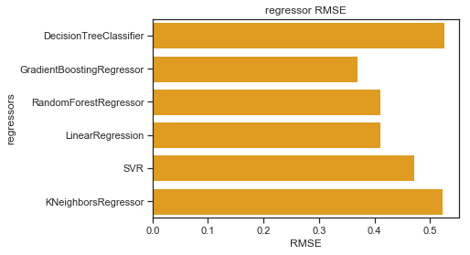 Figure 12. RMSE for Models

Summary
From all the above models, it was seen that Random Forest, Linear regression are the most accurate models. The focus lies in the preprocessing steps involved, the reason being, there were about two big imputations/changes in the dataset, one while dealing with missing values and another while dealing with outliers. Also, many ways of feature selection and combining of categories were available. Juggling with all these parameters and applying various permutations and combinations on the same, plus the domain knowledge would have helped near the best model. Only after this, the tuning and model building should have been done. Thus, there are several other ways and mixed approaches we could employ till we can eliminate previous models and reach to an optimal model.

From the observation Figure 11,12 of all RMSE Value and R-Squared Value we have concluded that Linear Regression Model has minimum value of RMSE, and its R-Squared Value is also maximum if we decide to treat the target as continuous variable. But if we decide to treat is categorical variable, it should be Random Forest.

Test run on selected Random Forest Model:
Accuracy 66.66 %
RMSE: 0.21798814736520367
Test run on selected Linear Regression Model:
R-squared: 0.950
RMSE: 0.32558901600799134

Q1. What changes company should bring to reduce the number of absenteeism?

The changes company can bring to reduce absenteeism hours is by cutting or improving in the areas where the absenteeism hours gets affected. For e.g. by observing graphs and plots in visualizations section, it was seen that oldest aged group of ~46,58 had tremendous shoot in absenteeism. The greatest number of instances (~21%) for the reason for absence was for medical consultation, thus having a half-yearly or quarterly checkup, or a doctor solely for company employees can also be appointed. It was also observed that workload was one of the important factors during the model building phase, so by bringing the workload to an optimized point which makes the employees avert absenteeism and the profits of the company also doesn’t degrade much can be put in work. There was about 5% of instances where employees didn’t justify the reason of absence, so stringent rules can be brought up against such employees. Like these, many other small changes can be brought up by the company, but broadly the above stated reasons would suffice. If absenteeism is a serious concern faced by the company, then it can invest in the areas stated while compromising little on profits

